**GENIE INDIA PILOT BRIEF | OAKEN GLOW SODA**

**ABOUT THE BRAND**

Once in a year comes a product that redefines the category, thinks differently, does differently and kicks off a new era. One such disruptor has been the launch of India’s first true smoky premium whisky: **SEAGRAMS OAKEN GLOW.**

In a market full of regular whiskies that cater to the traditional taste palette, here’s something that stands out with its differentiated taste.

Oaken Glow is an entry level premium whisky brand that embodies boldness & unconventionality. With its distinctive smoky flavor it appeals to individuals who dare to challenge the norms and embrace life.

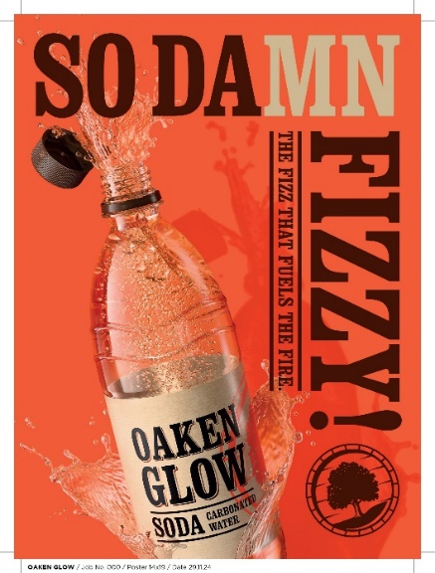It is a whisky made for bold moments whether that’s exploring unchartered paths or firing up the mundane moments with friends.

Ever since our launch in 2020, the brand has been communicating its product proposition of **A SMOKY TASTE CRAFTED BY FIRE** to our consumer at L3F

With this communication we want to ensure a distinct product proposition for the brand – to communicate what sets us apart from the sea of regular whiskies available to the consumer within the segment

We have taken our smoky proposition the consumer through our **product campaign**, **digital interventions** (product page on Social – which we were able to leverage only for a short time) and through **activations on the brand** which hinged on bringing alive the **BBQ experience a space we want to own with the brand**

We have recently launched our brand extension product – **OAKEN GLOW SODA.**

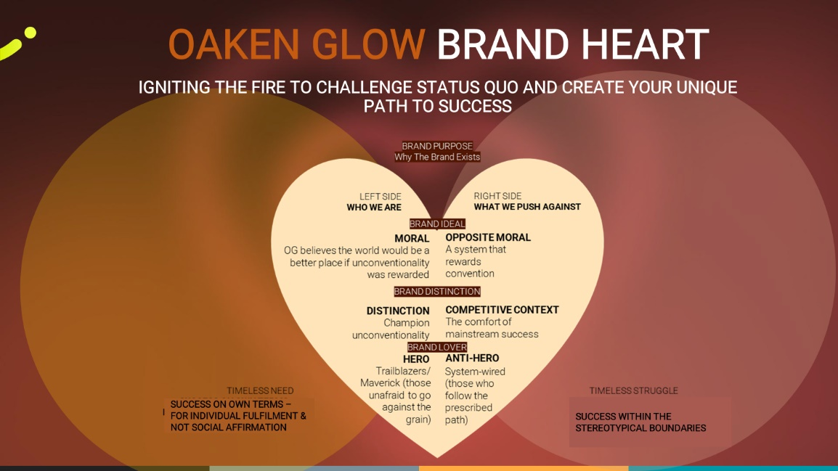

**MARKETING OBJECTIVE**

Oaken Glow is launching its brand extension of SODA which we want to amplify across platforms of social, ecomm and quick comm.

We want to do this by **LEVERAGING OUR MOC OF LIVELY PARTY WITH FOOD AS THE PERFECT BACK DROP**

The MOC is driven by a desire to let go, have fun and elevate the mood, food and alcohol greasing the social connections.

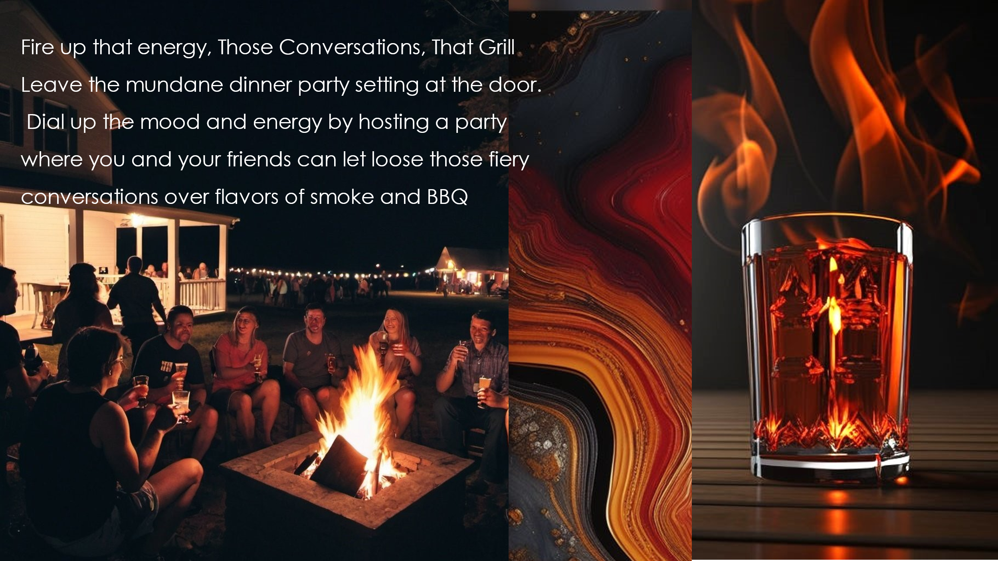

**TARGET AUDIENCE**

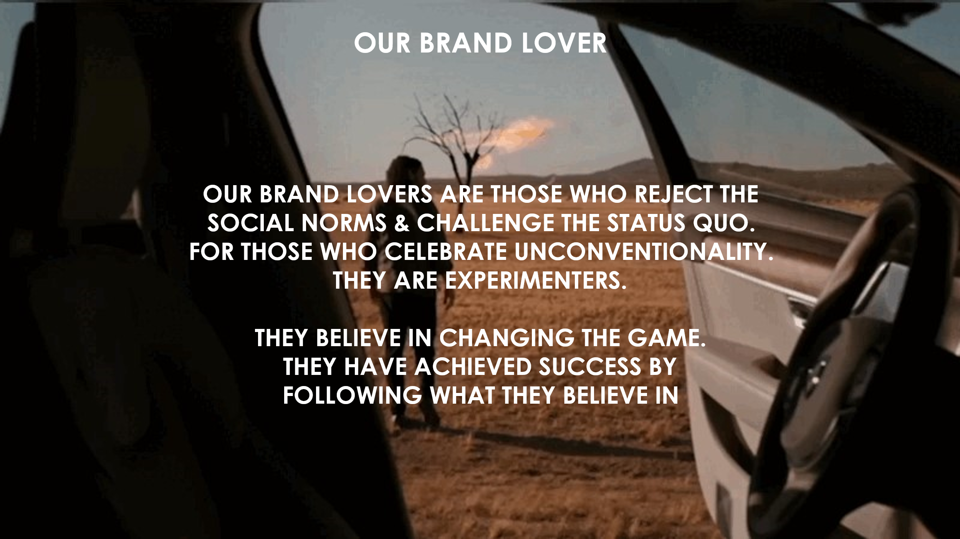Male, LDA – 30/32, NCCS AB, Metros and Tier 1. Young, unconventional thinkers, confident, self-believers, experimental and early adopters and are looking for a unique and differentiated offering.

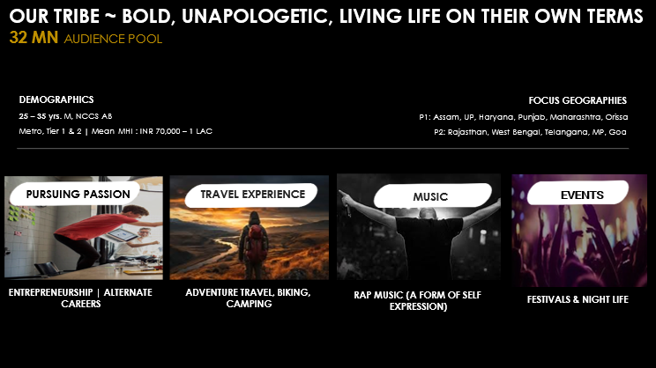

**WHAT ARE THE PILOT OBJECTIVES?**

P1 | Owning the MOC

**THE ASK**

* Leverage the Oaken Glow Soda brand extension to build salience with the MOC: *bringing together the sizzle of the bbq and the fizz of the soda*
* Create an image repository of the MOC that can be deployed as per requirement on digital platforms by the Brand teams and Brand Extension teams
* Benchmark: Pepsi’s GRILLS NIGHT OUT | GRILLING GETS BETTER WITH PEPSI campaign
* Platforms where the assets will be used  
  - Social (META)  
  - Quick Commerce (Swiggy Instamart, Zepto, BlinkIt)  
  - E-Commerce (Amazon)
* Total # of assets: 20 Statics
* Tone & Style: Bold, fun, high energy
* TG Passion Points: Adventure travel including (motorcycle) touring, camping - content environment to reflect these facets
* Reference/Moodboard: [Oaken Glow Genie Pilot Deck.pptx](https://pernodricard-my.sharepoint.com/:p:/g/personal/siddharth_virkar-ext_pernod-ricard_com/EXB5WYeTXlBEiwLh6pv_xyMB1gHJWDnDDfh3h9h8hItLGw?e=neYoFD)
* Extension Assets: [OG Extension Assets](https://pernodricard-my.sharepoint.com/:f:/g/personal/siddharth_virkar-ext_pernod-ricard_com/EmFCun9hpIVOqmO_xD8bNOsB3H_bUaC98V8Dt3920vKIBw?e=G2gE0d)

**TIMELINES**  
Phase 1: 10 Assets | Statics | March W4  
Phase 2: 10 Assets | Statics | April W4